Q) RISC vs CISC?
Ans:
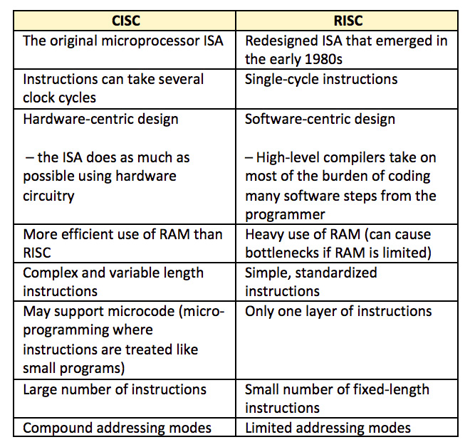

Q) RISC design philosophy
Ans:
1. Instructions—RISC processors have a reduced number of instruction classes. These
classes provide simple operations that can each execute in a single cycle. The compiler
or programmer synthesizes complicated operations (for example, a divide operation)
by combining several simple instructions. Each instruction is a fixed length to allow
the pipeline to fetch future instructions before decoding the current instruction.
2. Pipelines—The processing of instructions is broken down into smaller units that can be
executed in parallel by pipelines. Ideally the pipeline advances by one step on each cycle
for maximum throughput. Instructions can be decoded in one pipeline stage.
3. Registers—RISC machines have a large general-purpose register set. Any register can
contain either data or an address. Registers act as the fast local memory store for all data processing operations.
4. Load-store architecture—The processor operates on data held in registers. Separate load
and store instructions transfer data between the register bank and external memory.
Memory accesses are costly, so separating memory accesses from data processing pro-
vides an advantage because you can use data items held in the register bank multiple
times without needing multiple memory accesses.

Q) ARM Design philosophy?
Or
Things to take care while designing an ARM system?
Ans:
1) The ARM processor has been specifically designed to be small to reduce power consumption and extend battery operation.
2) High code density is another major requirement since embedded systems have limited memory due to cost and/or physical size restrictions.

3) The ability to use low-cost memory devices produces substantial savings.

4) Another important requirement is to reduce the area of the die taken up by the embedded
processor.

5) Incorporated hardware debug technology within the processor so that software
engineers can view what is happening while the processor is executing code.

Q) AMBA Bus Protocol?
Ans:
The Advanced Microcontroller Bus Architecture (AMBA) was introduced in 1996 and has
been widely adopted as the on-chip bus architecture used for ARM processors.
Different AMBA bus – ARM System Bus(ASB), ARM Peripheral Bus(APB) and ARM High Performance Bus (AHB).

Q) How AHB attains better performance?
Ans:
AHB provides higher data throughput than ASB because it is based on a centralized
multiplexed bus scheme rather than the ASB bidirectional bus design. This change allows
the AHB bus to run at higher clock speeds and to be the first ARM bus to support widths
of 64 and 128 bits. ARM has introduced two variations on the AHB bus: Multi-layer AHB
and AHB-Lite. In contrast to the original AHB, which allows a single bus master to be
active on the bus at any time, the Multi-layer AHB bus allows multiple active bus masters.
AHB-Lite is a subset of the AHB bus and it is limited to a single bus master. This bus was
developed for designs that do not require the full features of the standard AHB bus.

Q) How thumb instructions improve performance?
Ans:
If the core executes 16-bit Thumb instructions, it will achieve better performance with a 16-bit memory. The higher performance is a result of the core making only a single fetch to memory to load an instruction. Hence, using Thumb instructions with 16-bit-wide memory devices provides both improved performance and reduced cost.

ARM Processor Fundamentals

Q) ARM Core Data Flow model
Ans:
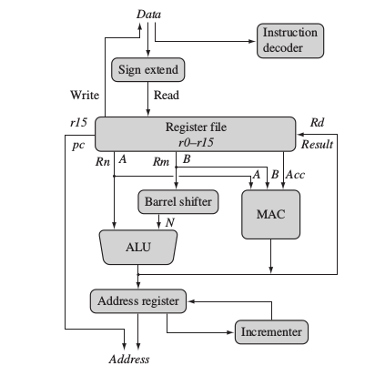

The arrows represent the flow of data, the lines represent the buses, and the boxes represent either an operation unit or a storage area.
Data enters the processor core through the Data bus. The data may be an instruction to
execute or a data item.
The instruction decoder translates instructions before they are executed. Each
instruction executed belongs to a particular instruction set.
The ARM processor, like all RISC processors, uses a load-store architecture. This
means it has two instruction types for transferring data in and out of the processor: load
instructions copy data from memory to registers in the core, and conversely the store instructions copy data from registers to memory. There are no data processing instructions
that directly manipulate data in memory. Thus, data processing is carried out solely in
registers.
Data items are placed in the register file—a storage bank made up of 32-bit registers.
Since the ARM core is a 32-bit processor, most instructions treat the registers as holding
signed or unsigned 32-bit values. The sign extend hardware converts signed 8-bit and 16-bit
numbers to 32-bit values as they are read from memory and placed in a register.
ARM instructions typically have two source registers, Rn and Rm, and a single result or
destination register, Rd. Source operands are read from the register file using the internal
buses A and B, respectively.
The ALU (arithmetic logic unit) or MAC (multiply-accumulate unit) takes the regis-
ter values Rn and Rm from the A and B buses and computes a result. Data processing
instructions write the result in Rd directly to the register file. Load and store instructions
use the ALU to generate an address to be held in the address register and broadcast on the
Address bus.
One important feature of the ARM is that register Rm alternatively can be preprocessed
in the barrel shifter before it enters the ALU. Together the barrel shifter and ALU can
calculate a wide range of expressions and addresses.
After passing through the functional units, the result in Rd is written back to the register
file using the Result bus. For load and store instructions the incrementer updates the address
register before the core reads or writes the next register value from or to the next sequential
memory location. The processor continues executing instructions until an exception or
interrupt changes the normal execution flow.

Q) Register details of ARM Core?
Ans:
r0-r12
r13(sp)
r14(lr)
r15(pc)
cpsr
spsr

All the registers shown are 32 bits in size.
There are up to 18 active registers: 16 data registers and 2 processor status registers. The
data registers are visible to the programmer as r0 to r15.
The ARM processor has three registers assigned to a particular task or special function:
r13, r14, and r15. They are frequently given different labels to differentiate them from the
other registers.
■ Register r13 is traditionally used as the stack pointer (sp) and stores the head of the stack
in the current processor mode.
■ Register r14 is called the link register (lr) and is where the core puts the return address
whenever it calls a subroutine.
■ Register r15 is the program count

Depending upon the context, registers r13 and r14 can also be used as general-purpose
registers, which can be particularly useful since these registers are banked during a processor
mode change.

In ARM state the registers r0 to r13 are orthogonal—any instruction that you can apply
to r0 you can equally well apply to any of the other registers. However, there are instructions
that treat r14 and r15 in a special way.

In addition to the 16 data registers, there are two program status registers: cpsr and spsr
(the current and saved program status registers, respectively).
The register file contains all the registers available to a programmer. Which registers are
visible to the programmer depend upon the current mode of the processor.

Q) CPSR register details
Ans:
The ARM core uses the cpsr to monitor and control internal operations. The cpsr is a
dedicated 32-bit register and resides in the register file.
The cpsr is divided into four fields, each 8 bits wide: flags, status, extension, and control.
In current designs the extension and status fields are reserved for future use. The control
field contains the processor mode, state, and interrupt mask bits. The flags field contains
the condition flags.
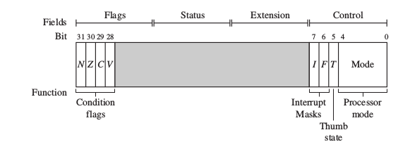

Q) Different processor modes in armv7?
Ans:
The processor mode determines which registers are active and the access rights to the cpsr
register itself. Each processor mode is either privileged or nonprivileged: A privileged mode
allows full read-write access to the cpsr. Conversely, a nonprivileged mode only allows read
access to the control field in the cpsr but still allows read-write access to the condition flags.

There are seven processor modes in total: six privileged modes (abort, fast interrupt
request, interrupt request, supervisor, system, and undefined) and one nonprivileged mode
(user).
The processor enters abort mode when there is a failed attempt to access memory.
Fast interrupt request and interrupt request modes correspond to the two interrupt levels available
on the ARM processor.
Supervisor mode is the mode that the processor is in after reset and is generally the mode that an operating system kernel operates in.
System mode is a special version of user mode that allows full read-write access to the cpsr. Undefined mode is used when the processor encounters an instruction that is undefined or not supported by the implementation.
User mode is used for programs and applications.

Q) Banked registers in arm?
Ans:
There are 37 registers in register file. Of those, 20 registers are hidden from
a program at different times. These registers are called banked registers and are identified
by the shading in the diagram. They are available only when the processor is in a particular mode.
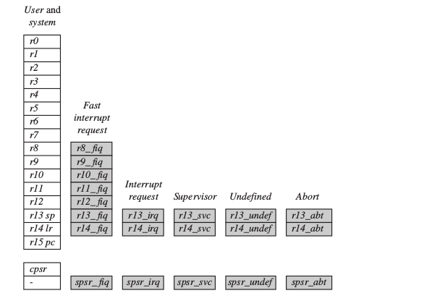

Banked registers of a particular mode are denoted by an underline character post-fixed to the mode
mnemonic or _mode.
Every processor mode except user mode can change mode by writing directly to the
mode bits of the cpsr. All processor modes except system mode have a set of associated
banked registers that are a subset of the main 16 registers. A banked register maps one-to-
one onto a user mode register. If you change processor mode, a banked register from the
new mode will replace an existing register.

Q) How the processor mode changes?
Ans:
The processor mode can be changed by a program that writes directly to the cpsr (the
processor core has to be in privileged mode) or by hardware when the core responds to an exception or interrupt. The following exceptions and interrupts cause a mode change:
reset, interrupt request, fast interrupt request, software interrupt, data abort, prefetch abort,
and undefined instruction. Exceptions and interrupts suspend the normal execution of
sequential instructions and jump to a specific location.

Q) How does the mode change from user mode to interrupt mode and back?
Ans:
the core changing from user mode to interrupt request mode, which happens when an
interrupt request occurs due to an external device raising an interrupt to the processor core.
This change causes user registers r13 and r14 to be banked. The user registers are replaced
with registers r13_irq and r14_irq, respectively. Note r14_irq contains the return address
and r13_irq contains the stack pointer for interrupt request mode. A new register appearing in interrupt request mode: the saved program status register (spsr), which stores the previous mode’s cpsr.

To return back to user mode, a special return instruction is used that instructs the core to restore the original cpsr from the spsr_irq and bank in the user registers r13 and r14. Note that the spsr can only be modified and read in a privileged mode. There is no spsr available in user mode.

Q) ARM Instruction Set vs Thumb Instruction Set?
Ans:
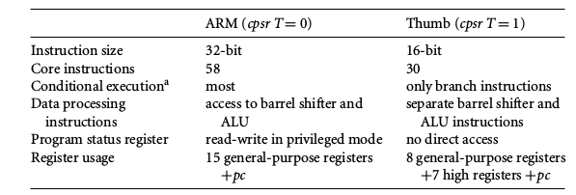
*

Q) Conditional Flags in CPSR?
Ans:
Condition flags are updated by comparisons and the result of ALU operations that specify
the S instruction suffix. For example, if a SUBS subtract instruction results in a register value
of zero, then the Z flag in the cpsr is set. This particular subtract instruction specifically
updates the cpsr.
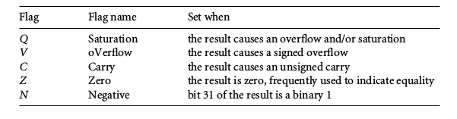
With processor cores that include the DSP extensions, the Q bit indicates if an overflow
or saturation has occurred in an enhanced DSP instruction. The flag is “sticky” in the
sense that the hardware only sets this flag. To clear the flag you need to write to the cpsr
directly.

Q) Conditional execution and mnemonics in arm isa?
Ans:
Conditional execution controls whether or not the core will execute an instruction.
Most instructions have a condition attribute that determines if the core will execute it
based on the setting of the condition flags. Prior to execution, the processor compares the
condition attribute with the condition flags in the cpsr. If they match, then the instruction
is executed; otherwise the instruction is ignored.
The condition attribute is postfixed to the instruction mnemonic, which is encoded
into the instruction.
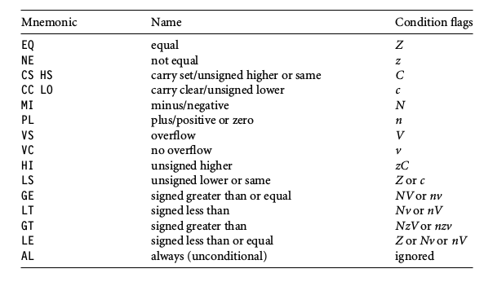

Q) Pipelining in ARM Processors?
Ans:
A pipeline is the mechanism a RISC processor uses to execute instructions. Using a pipeline
speeds up execution by fetching the next instruction while other instructions are being
decoded and executed.

Fetch ----> Decode ----> Execute (ARM7)

■ Fetch loads an instruction from memory.
■ Decode identifies the instruction to be executed.
■ Execute processes the instruction and writes the result back to a register.

The ARM9 core increases the pipeline length to five stages.
Fetch ----> Decode ----> Execute ----> Memory ----> Write

The ARM9 adds a memory and writeback stage.

The ARM10 increases the pipeline length still further by adding a sixth stage.
Fetch ----> Issue ----> Decode ----> Execute ----> Memory ----> Write

In the execute stage, the pc always points to the address of the instruction plus 8 bytes. In other words, the pc always points to the address of the instruction being executed plus two instructions
ahead.

There are three other characteristics of the pipeline worth mentioning.
First, the execution of a branch instruction or branching by the direct modification of the pc causes the ARM core to flush its pipeline.
Second, ARM10 uses branch prediction, which reduces the effect of a pipeline flush by
predicting possible branches and loading the new branch address prior to the execution of
the instruction.
Third, an instruction in the execute stage will complete even though an interrupt has
been raised. Other instructions in the pipeline will be abandoned, and the processor will
start filling the pipeline from the appropriate entry in the vector table.

Q) What is vector table? How is it used?
Ans:
When an exception or interrupt occurs, the processor sets the pc to a specific memory
address. The address is within a special address range called the vector table.
The entries in the vector table are instructions that branch to specific routines designed to handle a
particular exception or interrupt.
When an exception or interrupt occurs, the processor suspends normal execution and
starts loading instructions from the exception vector table.
Each vector table entry contains a form of branch instruction pointing to the start of a specific routine:
■ Reset vector is the location of the first instruction executed by the processor when power
is applied. This instruction branches to the initialization code.
■ Undefined instruction vector is used when the processor cannot decode an instruction.
■ Software interrupt vector is called when you execute a SWI instruction. The SWI
instruction is frequently used as the mechanism to invoke an operating system routine.
■ Prefetch abort vector occurs when the processor attempts to fetch an instruction from an
address without the correct access permissions. The actual abort occurs in the decode
stage.
■ Data abort vector is similar to a prefetch abort but is raised when an instruction attempts
to access data memory without the correct access permissions.
■ Interrupt request vector is used by external hardware to interrupt the normal execution
flow of the processor. It can only be raised if IRQs are not masked in the cpsr.
■ Fast interrupt request vector is similar to the interrupt request but is reserved for hardware
requiring faster response times. It can only be raised if FIQs are not masked in the cpsr.

Q) What are the different Core extensions found in ARM cores?
Ans:
There are three hardware extensions ARM wraps around the core:
cache and tightly coupled memory,
memory management,
and the coprocessor interface.

Q) ARM Cache core extension
Ans:
The cache is a block of fast memory placed between main memory and the core. It allows for
more efficient fetches from some memory types. With a cache the processor core can run
for the majority of the time without having to wait for data from slow external memory.
Most ARM-based embedded systems use a single-level cache internal to the processor.
Of course, many small embedded systems do not require the performance gains that a
cache brings.
ARM has two forms of cache.
The first is found attached to the Von Neumann–style cores. It combines both data and instruction into a single unified cache.
The second form, attached to the Harvard-style cores, has separate caches
for data and instruction.

Q) What is tightly coupled memory?
Ans:
On real-time systems it is paramount that code execution is deterministic—
the time taken for loading and storing instructions or data must be predictable. This is
achieved using a form of memory called tightly coupled memory (TCM). TCM is fast SRAM
located close to the core and guarantees the clock cycles required to fetch instructions or
data—critical for real-time algorithms requiring deterministic behavior. TCMs appear as
memory in the address map and can be accessed as fast memory.

Q) Differences between cache and TCM?
Ans:
1) Cache memory is implemented with on-chip memory and control logic. Tightly coupled memory is implemented with on-chip memory and a dedicated connection.
2) Tightly coupled memory has a fixed span in the address map. Cache serves as an intermediate between the processor and the memory to (hopefully) provide more efficient memory accesses.
3) Tightly coupled memory has deterministic access time. Accesses through the cache are not deterministic since the data will either live in the cache (hit) or the data must be fetched from main memory (miss).
4) Cache stores dynamically data/code which has been lately used in order to improve access speed. Every time a memory access is required, the processor checks if the required data is already present in the cache or must be newly fetched from memory; in the meantime, old unused cache data is being continously replaced with new data. Tightly coupled memory is also a fast access memory, since it exploits a dedicated port, but it has static content: you decide what you need there and you specify it in the linker script.

Q) Memory management hardware in ARM Cores?
Ans:
ARM cores have three different types of memory management hardware—no extensions
providing no protection, a memory protection unit (MPU) providing limited protection,
and a memory management unit (MMU) providing full protection:
■ Nonprotected memory is fixed and provides very little flexibility. It is normally used for
small, simple embedded systems that require no protection from rogue applications.
■ MPUs employ a simple system that uses a limited number of memory regions. These
regions are controlled with a set of special coprocessor registers, and each region is
defined with specific access permissions. This type of memory management is used
for systems that require memory protection but don’t have a complex memory map.
■ MMUs are the most comprehensive memory management hardware available on the
ARM. The MMU uses a set of translation tables to provide fine-grained control over
memory. These tables are stored in main memory and provide a virtual-to-physical
address map as well as access permissions. MMUs are designed for more sophisti-
cated platform operating systems that support multitasking.

Q) What is the use of ARM Coprocessors?
Ans:
A coprocessor extends the processing features of a core by extending the instruction set or by providing configuration registers. More than one coprocessor can be added to the ARM core via the coprocessor interface.
The coprocessor can be accessed through a group of dedicated ARM instructions
that provide a load-store type interface.
The coprocessor can also extend the instruction set by providing a specialized group
of new instructions.
These new instructions are processed in the decode stage of the ARM pipeline. If the
decode stage sees a coprocessor instruction, then it offers it to the relevant coprocessor.
But if the coprocessor is not present or doesn’t recognize the instruction, then the ARM
takes an undefined instruction exception, which allows you to emulate the behavior of the
coprocessor in software.

Q) What is EmbeddedICE macrocell?
Ans:
EmbeddedICE macrocell is the debug hardware built into the processor that allows
breakpoints and watchpoints to be set.

Q) Features of ARM7 family?
Ans:
The ARM7 core has a Von Neumann–style architecture, where both data and instructions
use the same bus. The core has a three-stage pipeline and executes the architecture ARMv4T
instruction set.

Q) What are frame pointers?
Ans:
Frame pointers assist the debug view by pointing to the local variables stored on the stack
frame. However, they are inefficient to maintain and shouldn’t be used in code critical to
performance.
The frame pointer ($fp) points to the start of the stack frame and does not move for the duration of the subroutine call. This points to the base of the stack frame, and the parameters that are passed in to the subroutine remain at a constant spot relative to the frame pointer.

CORTEX-M4

Cortex-M4 Features:

The Cortex-M4 processor is a low-power processor that features low gate count, low interrupt latency,and low-cost debug. The Cortex-M4 includes optional floating point arithmetic functionality. The processor is intended for deeply embedded applications that require fast interrupt response features.

- A processor core
- NVIC losely integrated with the processor core to achieve low-latency interrupt processing.
-Multiple high-performance bus interfaces.
-low-cost debug solution with the optional ability to:
— Implement breakpoints and code patches.
— Implement watchpoints, tracing, and system profiling.
— Support printf() style debugging.
— Bridge to a Trace Port Analyzer (TPA).
-option MPU
-optional FPU

External Interfaces:

The processor incorporates three external bus interfaces,
an ETM interface that allows the connection of an Embedded Trace Macrocell,
an AHB Trace Macrocell interface that enables simple connection of an ETM to the processor, and
an Advanced High-performance Bus Access Port (AHB-AP) interface for debug accesses.

The processor incorporates the following external interfaces:
• Multiple memory and device bus interfaces.
• ETM interface.
• Trace port interface.
• Debug port interface.

Configurable Options:
You can configure your Cortex-M4 implementation to include optional components, such as a Memory Protection Unit (MPU), a Flash Patch and Breakpoint Unit (FPB), and a Data Watchpoint and Trace Unit(DWT).

Optional Components:
• Memory Protection Unit (MPU) .• Flash Patch and Breakpoint Unit (FPB).• Data Watchpoint and Trace Unit (DWT).• Instrumentation Trace Macrocell Unit (ITM).• Embedded Trace Macrocell (ETM). See theETM-M4 Technical Reference Manual.• Advanced High-performance Bus Access Port (AHB-AP).• AHB Trace Macrocell (HTM) interface.• Trace Port Interface Unit (TPIU).• Wake-up Interrupt Controller (WIC).• Debug Port AHB-AP interface.• Floating-Point Unit (FPU).• Bit-banding.• Constant AHB control.

Architecture:
The processor implements the ARMv7E-M architecture profile.

Bus Architecture:
The processor implements an interface for CoreSight and other debug components using the AMBA 3APB protocol.

The processor provides three primary bus interfaces implementing a variant of the AMBA 3 AHB-Lite protocol.

Debug:
The debug features of the processor implement the ARM debug interface architecture.

Embedded Trace Macrocell:
The trace features of the processor implement the ARM Embedded Trace Macrocell architecture.

FPU
The Cortex-M4 FPU implements ARMv7E-M architecture with FPv4-SP extensions.

Cortex-M4 Block Diagram
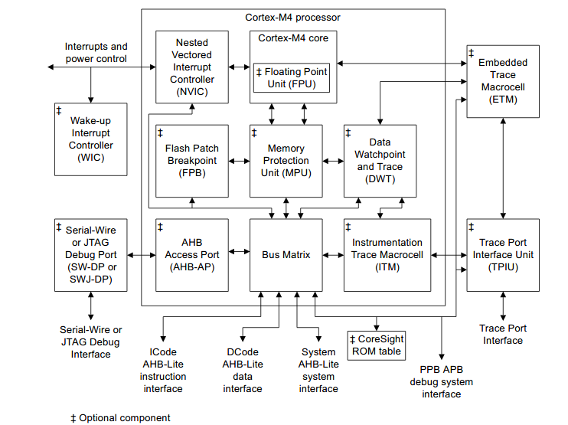
The complete processor features list comprises:
• A low gate count processor core, with low latency interrupt processing that has:
— A subset of the Thumb instruction set, defined in the ARM ® v7-M Architecture Reference Manual.
— Banked Stack Pointer (SP).
— Hardware integer divide instructions, SDIV and UDIV .
— Handler and Thread modes.
— Thumb and Debug states.
— Support for interruptible-continued instructions LDM , STM , PUSH , and POP for low interrupt latency.
— Automatic processor state saving and restoration for low latency Interrupt Service Routine (ISR)
entry and exit.
— Support for ARMv6 big-endian byte-invariant or little-endian accesses.
— Support for ARMv6 unaligned accesses.

Optional Floating Point Unit (FPU) providing:
— 32-bit instructions for single-precision (C float) data-processing operations.
— Combined Multiply and Accumulate instructions for increased precision (Fused MAC).
— Hardware support for conversion, addition, subtraction, multiplication with optional accumulate,
division, and square-root.
— Hardware support for denormals and all IEEE rounding modes.
— 32 dedicated 32-bit single-precision registers, also addressable as 16 double-word registers.
— Decoupled three stage pipeline.

Nested Vectored Interrupt Controller (NVIC) closely integrated with the processor core to achieve
low-latency interrupt processing. Features include:
— External interrupts, configurable from 1 to 240.
— Bits of priority, configurable from 3 to 8.
— Dynamic reprioritization of interrupts.
— Priority grouping. This enables selection of preempting interrupt levels and non preempting
interrupt levels.
— Support for tail-chaining and late arrival of interrupts. This enables back-to-back interrupt
processing without the overhead of state saving and restoration between interrupts.
— Processor state automatically saved on interrupt entry, and restored on interrupt exit, with no
instruction overhead.
— Optional Wake-up Interrupt Controller (WIC), providing ultra-low-power sleep mode support.

Memory Protection Unit (MPU). An optional MPU for memory protection, including:
— Eight memory regions.
— Sub Region Disable (SRD), enabling efficient use of memory regions.
— The ability to enable a background region that implements the default memory map attributes.

Bus interfaces:
— Three Advanced High-performance Bus-Lite (AHB-Lite) interfaces: ICode, DCode, and System
bus interfaces.
— Private Peripheral Bus (PPB) based on Advanced Peripheral Bus (APB) interface.
— Bit-band support that includes atomic bit-band write and read operations.
— Memory access alignment.
— Write buffer for buffering of write data.
— Exclusive access transfers for multiprocessor systems.

Low-cost debug solution that features:
— Debug access to all memory and registers in the system, including access to memory-mapped
devices, access to internal core registers when the core is halted, and access to debug control
registers even while SYSRESETn is asserted.
— Serial Wire Debug Port (SW-DP) or Serial Wire JTAG Debug Port (SWJ-DP) debug access.
— Optional Flash Patch and Breakpoint (FPB) unit for implementing breakpoints and code patches.
— Optional Data Watchpoint and Trace (DWT) unit for implementing watchpoints, data tracing, and system profiling.
— Optional Instrumentation Trace Macrocell (ITM) for support of printf() style debugging.
— Optional Trace Port Interface Unit (TPIU) for bridging to a Trace Port Analyzer (TPA),
including Single Wire Output (SWO) mode.
— Optional Embedded Trace Macrocell (ETM) for instruction trace.

Bus Interfaces:
The Cortex-M4 processor contains three external Advanced High-performance Bus (AHB)-Lite bus
interfaces and one Advanced Peripheral Bus (APB) interface.

ICode memory interface
Instruction fetches from Code memory space, 0x00000000 to 0x1FFFFFFC , are performed over the 32-bit AHB-Lite bus.
The Debugger cannot access this interface. All fetches are word-wide. The number of instructions
fetched per word depends on the code running and the alignment of the code in memory.

DCode memory interface
Data and debug accesses to Code memory space, 0x00000000 to 0x1FFFFFFF , are performed over the 32-bit AHB-Lite bus.
The Code memory space available is dependent on the implementation. Core data accesses have a higher priority than debug accesses on this bus. This means that debug accesses are waited until core accesses have completed when there are simultaneous core and debug access to this bus.
Control logic in this interface converts unaligned data and debug accesses into two or three aligned
accesses, depending on the size and alignment of the unaligned access.

System interface
Instruction fetches and data and debug accesses to address ranges 0x20000000 to 0xDFFFFFFF and
0xE0100000 to 0xFFFFFFFF are performed over the 32-bit AHB-Lite bus.
For simultaneous accesses to the 32-bit AHB-Lite bus, the arbitration order in decreasing priority is:
• Data accesses.
• Instruction and vector fetches.
• Debug.
The system bus interface contains control logic to handle unaligned accesses, FPB remapped accesses, bit-band accesses, and pipelined instruction fetches.

Programmer’s Model

The Cortex-M4 processor supports Thread and Handler operating modes, and may be run in Thumb or Debug operating states. In addition, the processor can limit or exclude access to some resources by executing code in privileged or unprivileged mode.

Operating modes
The conditions which cause the processor to enter Thread or Handler mode are as follows:
• The processor enters Thread mode on Reset, or as a result of an exception return. Privileged and
Unprivileged code can run in Thread mode.
• The processor enters Handler mode as a result of an exception. All code is privileged in Handler
mode.

Operating states
The processor can operate in thumb or debug state:
• Thumb state. This is normal execution running 16-bit and 32-bit halfword aligned Thumb
instructions.
• Debug State. This is the state when the processor is in halting debug.

Privileged access and user access
Handler mode is always privileged. Thread mode can be privileged or unprivileged.

Instruction set summary
The processor implements the ARMv7-M Thumb instruction set, and is binary compatible with the
instruction sets and features implemented in other Cortex-M profile processors. Instructions can be
paired in a way that achieves optimum reductions in timing.

Zero wait state is a feature of a processor or computer architecture in which the processor does not have to wait to perform memory access. Non-zero wait state describes the situation when a processor operates at a higher frequency than the memory, it has a wait state during which the processor is idle.

Within the assembler syntax, depending on the operation, the <op2> field can be replaced with one of the following options:
• A simple register specifier, for example Rm .
• An immediate shifted register, for example Rm, LSL #4 .
• A register shifted register, for example Rm, LSL Rs.
• An immediate value, for example #0xE000E000 .

Processor Memory Model:

Address Map:
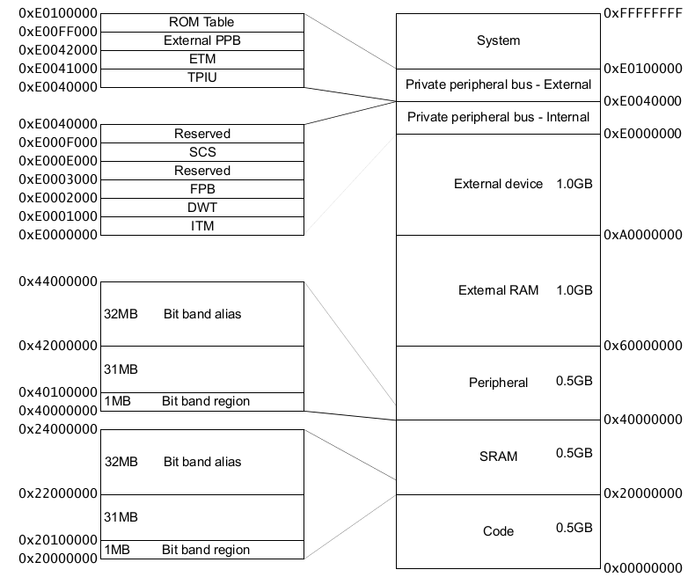
Code | Instruction fetches are performed over the ICode bus. Data accesses are performed over the DCode bus.
SRAM | Instruction fetches and data accesses are performed over the system bus.
SRAM bit-band | Alias region. Data accesses are aliases. Instruction accesses are not aliases.
Peripheral | Instruction fetches and data accesses are performed over the system bus.
Peripheral bit-band | Alias region. Data accesses are aliases. Instruction accesses are not aliases.
External RAM | Instruction fetches and data accesses are performed over the system bus.
External Device | Instruction fetches and data accesses are performed over the system bus.
Private Peripheral Bus | External and internal Private Peripheral Bus (PPB) interfaces.  This memory region is Execute Never (XN), and so instruction fetches are prohibited. An MPU, if present, cannot change this.
System | System segment for vendor system peripherals. This memory region is XN, and so instruction fetches are  prohibited. An MPU, if present, cannot change this.

Private Peripheral Bus
The Private Peripheral Bus (PPB) interface provides access to internal and external processor resources.

The internal Private Peripheral Bus (PPB) interface provides access to:
• The Instrumentation Trace Macrocell (ITM).
• The Data Watchpoint and Trace (DWT).
• The Flashpatch and Breakpoint (FPB).
• The System Control Space (SCS), including the Memory Protection Unit (MPU) and the Nested
Vectored Interrupt Controller (NVIC).

The external PPB interface provides access to:
•The Trace Point Interface Unit (TPIU).
•The Embedded Trace Macrocell (ETM).
•The ROM table.
•Implementation-specific areas of the PPB memory map.

Unaligned accesses that cross regions
The Cortex-M4 processor supports ARMv7 unaligned accesses, and performs all accesses as single,
unaligned accesses. They are converted into two or more aligned accesses by the DCode and System bus interfaces.
Note: All Cortex-M4 external accesses are aligned.

Unaligned support is only available for load/store singles ( LDR , LDRH, STR, STRH ). Load/store double already supports word aligned accesses, but does not permit other unaligned accesses, and generates a fault if this is attempted

Write buffer
To prevent bus wait cycles from stalling the processor during data stores, buffered stores to the Dcode and System buses go through a one-entry write buffer. If the write buffer is full, subsequent accesses to the bus stall until the write buffer has drained.
The write buffer is only used if the bus waits the data phase of the buffered store, otherwise the
transaction completes on the bus.

Exclusive monitor
The Cortex-M4 processor implements a local exclusive monitor. The local monitor within the processor has been constructed so that it does not hold any physical address, but instead treats any access as matching the address of the previous LDREX. This means that the implemented exclusives reservation granule is the entire memory address range.
The Cortex-M4 processor does not support exclusive accesses to bit-band regions.

Bit-banding
Bit-banding is an optional feature of the Cortex-M4 processor. Bit-banding maps a complete word of memory onto a single bit in the bit-band region. For example, writing to one of the alias words sets or clears the corresponding bit in the bit-band region.
Bit-banding enables every individual bit in the bit-banding region to be directly accessible from a word-aligned address using a single LDR instruction. It also enables individual bits to be toggled without performing a read-modify-write sequence of instructions.

The processor memory map includes two bit-band regions. These occupy the lowest 1MB of the SRAM and Peripheral memory regions respectively. These bit-band regions map each word in an alias region of memory to a bit in a bit-band region of memory.

The System bus interface contains logic that controls bit-band accesses as follows:
-It remaps bit-band alias addresses to the bit-band region.
-For reads, it extracts the requested bit from the read byte, and returns this in the Least Significant Bit (LSB) of the read data returned to the core.
-For writes, it converts the write to an atomic read-modify-write operation.
-The processor does not stall during bit-band operations unless it attempts to access the System bus
while the bit-band operation is being carried out.

The memory map has two 32MB alias regions that map to two 1MB bit-band regions:
-Accesses to the 32MB SRAM alias region map to the 1MB SRAM bit-band region.
-Accesses to the 32MB peripheral alias region map to the 1MB peripheral bit-band region.

A mapping formula shows how to reference each word in the alias region to a corresponding bit, or
target bit, in the bit-band region. The mapping formula is:
bit_word_offset = (byte_offset × 32) + (bit_number × 4)
bit_word_addr = bit_band_base + bit_word_offset
where:
-bit_word_offset is the position of the target bit in the bit-band memory region.
-bit_word_addr is the address of the word in the alias memory region that maps to the targeted bit.
-bit_band_base is the starting address of the alias region.
-byte_offset is the number of the byte in the bit-band region that contains the targeted bit.
-bit_number is the bit position, 0 to 7, of the targeted bit.

Processor core register summary
The processor has 32-registers that includes 13 general-purpose registers and several special-purpose registers.
The processor has the following 32-bit registers:
• 13 general-purpose registers, R0-R12.
• Stack Pointer (SP), R13 alias of banked registers, SP_process and SP_main.
• Link Register (LR), R14.
• Program Counter (PC), R15.
• Special-purpose Program Status Registers, (xPSR).

The general-purpose registers R0-R12 have no special architecturally-defined uses. Most instructions that can specify a general-purpose register can specify R0-R12.
Low registers
Registers R0-R7 are accessible by all instructions that specify a general-purpose register.

High registers
Registers R8-R12 are accessible by all 32-bit instructions that specify a general-purpose
register.
Registers R8-R12 are not accessible by most 16-bit instructions.
Registers R13, R14, and R15 have the following special functions:
Stack pointer
Register R13 is used as the Stack Pointer (SP). Because the SP ignores writes to bits [1:0], it is
autoaligned to a word, four-byte boundary.
Handler mode always uses SP_main, but you can configure Thread mode to use either SP_main
or SP_process.

Link register
Register R14 is the subroutine Link Register (LR).
The LR receives the return address from PC when a Branch and Link ( BL ) or Branch and Link
with Exchange ( BLX ) instruction is executed.
The LR is also used for exception return.
At all other times, you can treat R14 as a general-purpose register.

Program counter
Register R15 is the Program Counter (PC).
Bit [0] is always 0, so instructions are always aligned to word or halfword boundaries.

Exceptions
Exceptions are handled and prioritized by the processor and the NVIC. In addition to architecturally
defined behavior, the processor implements advanced exception and interrupt handling that reduces
interrupt latency and includes implementation defined behavior.

When handling exceptions:
• All exceptions are handled in Handler mode.
• Processor state is automatically stored to the stack on an exception, and automatically restored from the stack at the end of the Interrupt Service Routine (ISR).
• The vector is fetched in parallel to the state saving, enabling efficient interrupt entry.

The processor supports tail-chaining that enables back-to-back interrupts without the overhead of state saving and restoration.
You configure the number of interrupts, and bits of interrupt priority, during implementation. Software can choose only to enable a subset of the configured number of interrupts, and can choose how many bits of the configured priorities to use.

Vector table entries are compatible with interworking between ARM and Thumb instructions. This
causes bit [0] of the vector value to load into the Execution Program Status Register (EPSR) T-bit on exception entry. All populated vectors in the vector table entries must have bit [0] set. Creating a table entry with bit [0] clear generates an INVSTATE fault on the first instruction of the handler
corresponding to this vector.

To reduce interrupt latency, the processor implements both interrupt late-arrival and interrupt tail-
chaining mechanisms, as defined by the ARMv7-M architecture:
• There is a maximum of a twelve cycle latency from asserting the interrupt to execution of the first
instruction of the ISR when the memory being accessed has no wait states being applied. When the
FPU option is implemented and a floating point context is active and the lazy stacking is not enabled, this maximum latency is increased to twenty nine cycles. The first instructions to be executed are fetched in parallel to the stack push.

Returns from interrupts similarly take ten cycles where the instruction being returned to is fetched in parallel to the stack pop. If the floating point option is implemented and an active floating point
context is included in the stack frame, the return from interrupt takes twenty-seven cycles.

Tail chaining requires six cycles when using zero wait state memory. No stack pushes or pops are
performed and only the instruction for the next ISR is fetched.

The processor exception model has the following implementation-defined behavior in addition to the architecturally defined behavior:
- Exceptions on stacking from HardFault to NMI lockup at NMI priority.
- Exceptions on unstacking from NMI to HardFault lockup at HardFault priority.

To minimize interrupt latency, the processor abandons any divide instruction to take any pending
interrupt. On return from the interrupt handler, the processor restarts the divide instruction from the
beginning. The processor implements the Interruptible-continuable Instruction field. Load multiple ( LDM ) operations and store multiple ( STM ) operations are interruptible. The EPSR holds the information required to continue the load or store multiple from the point where the interrupt occurred.

System Cotrol Registers

Important System Control Registers include:

ACTLR - Auxiliary Control Register, ACTLR
SysTick Registers(4)
CPUID
ICSR - Interrupt Control and State Register
VTOR - Vector Table Offset Register
SCR - System Control Register
CCR - Configuration and Control Register
System Handler Priority Registers (4)
Fault Status Registers(3)
AFSR - Auxiliary Fault Status Register
Processor Feature Registers
Memory Model Feature Registers
Instruction Set Attributes Registers
CPACR - Coprocessor Access Control Register
STIR - Software Triggered Interrupt Register

Memory Protection Unit

The MPU enforces privilege rules, separates processes, and enforces access rules to memory. The MPU is an optional component and supports the standard ARMv7 Protected Memory System Architecture model.

The MPU provides full support for:
• Protection regions.
• Overlapping protection regions, with ascending region priority:
— 7 = highest priority.
— 0 = lowest priority.
• Access permissions.
• Exporting memory attributes to the system.
MPU mismatches and permission violations invoke the programmable-priority MemManage fault
handler.

The access permission bits, TEX, C, B, AP, and XN, of the Region Access Control Register control
access to the corresponding memory region. If an access is made to an area of memory without the
required permissions, a permission fault is raised.

NVIC
The NVIC provides configurable interrupt handling abilities to the processor, facilitates low- latency exception and interrupt handling, and controls power management.

The NVIC supports up to 240 interrupts, each with up to 256 levels of priority that can be changed
dynamically.The processor and NVIC can be put into a very low-power sleep mode, leaving the WakeUp Controller (WIC) to identify and prioritize interrupts. Also, the processor supports both level and pulse interrupts.

The NVIC and the processor core interface are closely coupled, to enable low latency interrupt
processing and efficient processing of late arriving interrupts. The NVIC maintains knowledge of the stacked, or nested, interrupts to enable tail-chaining of interrupts. You can only fully access the NVIC from privileged mode, but you can cause interrupts to enter a pending state in user mode if you enable the Configuration and Control Register. Any other user mode access causes a bus fault.

NVIC registers are located within the SCS.

All NVIC registers and system debug registers are little-endian regardless of the endianness state of the processor.

The processor fully implements the Wait For Interrupt ( WFI ), Wait For Event ( WFE ) and the Send Event ( SEV ) instructions. In addition, the processor also supports the use of SLEEPONEXIT, that causes the processor core to enter sleep mode when it returns from an exception handler to Thread mode.

Level versus pulse interrupts
The processor supports both level and pulse interrupts. A level interrupt is held asserted until it is cleared by the ISR accessing the device. A pulse interrupt is a variant of an edge model.
You must ensure that the pulse is sampled on the rising edge of the Cortex-M4 clock, FCLK.

For level interrupts, if the signal is not deasserted before the return from the interrupt routine, the
interrupt again enters the pending state and re-activates.
A pulse interrupt can be reasserted during the ISR so that the interrupt can be in the pending state and active at the same time. If another pulse arrives while the interrupt is still pending, the interrupt remains pending and the ISR runs only once.
Pulse interrupts are mostly used for external signals and for rate or repeat signals.

FPU
The Cortex-M4 FPU is an implementation of the single precision variant of the ARMv7-M Floating- Point Extension (FPv4-SP). It provides floating-point computation functionality that is compliant with the ANSI/IEEE Std 754-2008, IEEE Standard for Binary Floating-Point Arithmetic, referred to as the IEEE 754 standard.

The FPU fully supports single-precision add, subtract, multiply, divide, multiply and accumulate, and square root operations. It also provides conversions between fixed-point and floating-point data formats, and floating-point constant instructions.

FPU views of the register bank
The FPU provides an extension register file containing 32 single-precision registers.
These can be viewed as:
• Sixteen 64-bit doubleword registers, D0-D15.
• Thirty-two 32-bit single-word registers, S0-S31.
• A combination of registers from these views:

The mapping between the registers is as follows:
• S<2n> maps to the least significant half of D<n> .
• S<2n+1> maps to the most significant half of D<n> .

For example, you can access the least significant half of the value in D6 by accessing S12 , and the most significant half of the elements by accessing S13 .

Modes of operation
The FPU provided full-compliance, flush-to-zero, and default NaN modes of operation.

Full-compliance mode
In full-compliance mode, the FPU processes all operations according to the IEEE 754 standard in
hardware.

Flush-to-zero mode
Setting the FZ bit of the Floating-point Status and Control Register FPSCR[24], enables flush-to-zero mode. In this mode, the FPU treats all subnormal input operands of arithmetic CDP operations as zeros in the operation. Exceptions that result from a zero operand are signaled appropriately.

Default NaN mode
Setting the DN bit, FPSCR[25], enables default NaN mode. In this mode, the result of any arithmetic data processing operation that involves an input NaN, or that generates a NaN result, returns the default NaN.
In computing, NaN, standing for not a number, is a member of a numeric data type that can be interpreted as a value that is undefined or unrepresentable, especially in floating-point arithmetic.

When Default NaN (DN) and Flush-to-Zero (FZ) modes are disabled, FPv4 functionality is compliant with the IEEE 754 standard in hardware. No support code is required to achieve this compliance.

The processor can reduce the exception latency by using lazy stacking. This means that the processor reserves space on the stack for the FP state, but does not save that state information to the stack unless the processor executes an FPU instruction in the current exception handler.

The lazy save of the FP state is interruptible by a higher priority exception. The FP state saving operation starts over after that exception returns.

Enabling the FPU
The processor must be in privileged mode to read from and write to the CPACR.

; CPACR is located at address 0xE000ED88
LDR.W R0, 0xE000ED88
; Read CPACR
LDR R1, [R0]
Set bits 20-23 to enable CP10 and CP11 coprocessors
ORR R1, R1, # 0xF << 20)
; Write back the modified value to the CPACR
STR R1, [R0]

Q) How Cortex-M4 attains low interrupt latency?
Ans:
The tight integration of the processor core and NVIC provides fast execution of Interrupt Service
Routines (ISRs), dramatically reducing the interrupt latency. This is achieved through the
hardware stacking of registers, and the ability to suspend load-multiple and store-multiple
operations. Interrupt handlers do not require wrapping in assembler code, removing any code
overhead from the ISRs. A tail-chain optimization also significantly reduces the overhead when
switching from one ISR to another.

Q) What are the features of Cortex-M4 processor?
Ans:
-tight integration of system peripherals reduces area and development costs
-Thumb instruction set combines high code density with 32-bit performance
-optional IEEE754-compliant single-precision FPU
-code-patch ability for ROM system updates
-power control optimization of system components
-integrated sleep modes for low power consumption
-fast code execution permits slower processor clock or increases sleep mode time
-hardware division and fast digital-signal-processing orientated multiply accumulate
-saturating arithmetic for signal processing
-deterministic, high-performance interrupt handling for time-critical applications
-optional Memory Protection Unit (MPU) for safety-critical applications
-extensive implementation-defined debug and trace capabilities:

Q) What are the peripherals in Cortex-M4?
Ans:
Nested Vectored Interrupt Controller
The NVIC is an embedded interrupt controller that supports low latency interrupt
processing.

System Control Block
The System Control Block (SCB) is the programmers model interface to the
processor. It provides system implementation information and system control,
including configuration, control, and reporting of system exceptions.

System timer
The system timer, SysTick, is a 24-bit count-down timer. Use this as a Real Time
Operating System (RTOS) tick timer or as a simple counter.

Memory Protection Unit
The Memory Protection Unit (MPU) improves system reliability by defining the
memory attributes for different memory regions. It provides up to eight different
regions, and an optional predefined background region.

Floating-point Unit
The Floating-Point Unit (FPU) provides IEEE754-compliant operations on
single-precision, 32-bit, floating-point values.

Q) Describe the programmer’s model of Cortex-M4?
Ans:

Processor Modes
The processor modes are:
Thread mode Used to execute application software. The processor enters Thread mode
when it comes out of reset.
Handler mode Used to handle exceptions. The processor returns to Thread mode when it
has finished all exception processing.

Privilege Levels
The privilege levels for software execution are:

Unprivileged
The software:
• has limited access to the MSR and MRS instructions, and cannot use the
CPS instruction
• cannot access the system timer, NVIC, or system control block
• might have restricted access to memory or peripherals.
Unprivileged software executes at the unprivileged level.

Privileged
The software can use all the instructions and has access to all resources.
Privileged software executes at the privileged level.

In Thread mode, the CONTROL register controls whether software execution is privileged or
unprivileged. In Handler mode, software execution is always privileged.
Only privileged software can write to the CONTROL register to change the privilege level for
software execution in Thread mode. Unprivileged software can use the SVC instruction to make
a supervisor call to transfer control to privileged software.

Core Registers
R0-R12
SP(R13) – MSP/PSP
LR(R14)
PC(R15)

PSR – Program Status Register – APSR/IPSR/EPSR
PRIMASK
FAULTMASK
BASEPRI
CONTROL

SP
The Stack Pointer (SP) is register R13. In Thread mode, bit[1] of the CONTROL register
indicates the stack pointer to use:
• 0 = Main Stack Pointer (MSP). This is the reset value.
• 1 = Process Stack Pointer (PSP).
On reset, the processor loads the MSP with the value from address 0x00000000 .

Link Register
The Link Register (LR) is register R14. It stores the return information for subroutines, function
calls, and exceptions. On reset, the processor sets the LR value to 0xFFFFFFFF.

Program Counter
The Program Counter (PC) is register R15. It contains the current program address. On reset,
the processor loads the PC with the value of the reset vector, which is at address 0x00000004 .
Bit[0] of the value is loaded into the EPSR T-bit at reset and must be 1.

Program Status Register
The Program Status Register (PSR) combines:
• Application Program Status Register (APSR)
• Interrupt Program Status Register (IPSR)
• Execution Program Status Register (EPSR).
These registers are mutually exclusive bitfields in the 32-bit PSR. The bit assignments are:
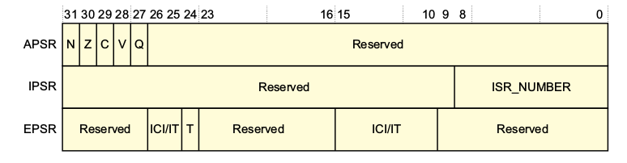
Access these registers individually or as a combination of any two or all three registers, using
the register name as an argument to the MSR or MRS instructions. For example:
• read all of the registers using PSR with the MRS instruction
• write to the APSR N, Z, C, V, and Q bits using APSR_nzcvq with the MSR instruction.

APSR
The APSR contains the current state of the condition flags from previous instruction executions.
Bits Name Function
[31] N Negative flag
[30] Z Zero flag
[29] C Carry or borrow flag
[28] V Overflow flag
[27] Q DSP overflow and saturation flag
[19:16] GE[3:0] Greater than or Equal flags.

IPSR
The IPSR contains the exception type number of the current Interrupt Service Routine (ISR).
Bits Name Function
[8:0] ISR_NUMBER This is the number of the current exception:

0 = Thread mode
1 = Reserved
2 = NMI
3 = HardFault
4 = MemManage
5 = BusFault
6 = UsageFault
7-10 = Reserved
11 = SVCall
12 = Reserved for Debug
13 = Reserved
14 = PendSV
15 = SysTick
16 = IRQ0.
.
.
.
n+15 = IRQ(n-1)^a (a. The number of interrupts, n, is implementation-defined,)

EPSR
The EPSR contains the Thumb state bit, and the execution state bits for either the:
• If-Then (IT) instruction
• Interruptible-Continuable Instruction (ICI) field for an interrupted load multiple or store
multiple instruction.

Attempts to read the EPSR directly through application software using the MSR instruction
always return zero. Attempts to write the EPSR using the MSR instruction in application software
are ignored.

Interruptible-continuable instructions
When an interrupt occurs during the execution of an LDM , STM , PUSH , or POP instruction, and when an FPU is implemented an VLDM , VSTM , VPUSH , or VPOP instruction, the processor:
• stops the load multiple or store multiple instruction operation temporarily
• stores the next register operand in the multiple operation to EPSR bits[15:12].
After servicing the interrupt, the processor:
•returns to the register pointed to by bits[15:12]
•resumes execution of the multiple load or store instruction.
When the EPSR holds ICI execution state, bits[26:25,11:10] are zero.

If-Then block
The If-Then block contains up to four instructions following an IT instruction. Each instruction
in the block is conditional. The conditions for the instructions are either all the same, or some
can be the inverse of others

Thumb state
The Cortex-M4 processor only supports execution of instructions in Thumb state. The following
can clear the T bit to 0:
• instructions BLX , BX and POP{PC }
• restoration from the stacked xPSR value on an exception return
• bit[0] of the vector value on an exception entry or reset.

Exception mask registers
The exception mask registers disable the handling of exceptions by the processor. Disable
exceptions where they might impact on timing critical tasks.
To access the exception mask registers use the MSR and MRS instructions, or the CPS instruction to change the value of PRIMASK or FAULTMASK.
The PRIMASK register prevents activation of all exceptions with configurable priority.
The FAULTMASK register prevents activation of all exceptions except for Non-Maskable
Interrupt (NMI). The processor clears the FAULTMASK bit to 0 on exit from any exception handler except the NMI handler.

The BASEPRI register defines the minimum priority for exception processing. When BASEPRI
is set to a nonzero value, it prevents the activation of all exceptions with the same or lower
priority level as the BASEPRI value.

The CONTROL register controls the stack used and the privilege level for software execution
when the processor is in Thread mode and, if implemented, indicates whether the FPU state is
active.
Bits Name Function
2 FPCA When floating-point is implemented this bit indicates whether context floating-point is currently active:
0 = no floating-point context active
1 = floating-point context active.
The Cortex-M4 uses this bit to determine whether to preserve floating-point state when processing an exception.

1 SPSEL Defines the currently active stack pointer: In Handler mode this bit reads as zero and ignores writes. The Cortex-M4 updates this bit automatically on exception return:
0 = MSP is the current stack pointer
1 = PSP is the current stack pointer.

0 nPRIV Defines the Thread mode privilege level:
0 = privileged
1 = unprivileged.

Handler mode always uses the MSP, so the processor ignores explicit writes to the active stack
pointer bit of the CONTROL register when in Handler mode. The exception entry and return
mechanisms automatically update the CONTROL register based on the EXC_RETURN value.

In an OS environment, ARM recommends that threads running in Thread mode use the process
stack and the kernel and exception handlers use the main stack.

Exceptions and Interrupts
The Cortex-M4 processor supports interrupts and system exceptions. The processor and the
NVIC prioritize and handle all exceptions. An exception changes the normal flow of software
control. The processor uses Handler mode to handle all exceptions except for reset.
The NVIC registers control interrupt handling.

DataTypes
supports the following data types:
— 32-bit words
— 16-bit halfwords
— 8-bit bytes

manages all data memory accesses as little-endian or big-endian. Instruction memory and
Private Peripheral Bus (PPB) accesses are always performed as little-endian.

The Cortex Microcontroller Software Interface Standard

For a Cortex-M4 microcontroller system, the Cortex Microcontroller Software Interface
Standard (CMSIS) defines:
•a common way to:
— access peripheral registers
— define exception vectors.
•the names of:
— the registers of the core peripherals
— the core exception vectors.
•a device-independent interface for RTOS kernels, including a debug channel.

The CMSIS includes address definitions and data structures for the core peripherals in the
Cortex-M4 processor.

CMSIS simplifies software development by enabling the reuse of template code and the
combination of CMSIS-compliant software components from various middleware vendors.
Software vendors can expand the CMSIS to include their peripheral definitions and access
functions for those peripherals.

Q) Describe the memory model of Cortex-M4?
Ans:
Describes the processor memory map, the behavior of memory accesses, and the
optional bit-banding features. The processor has a fixed default memory map that provides up
to 4GB of addressable memory.
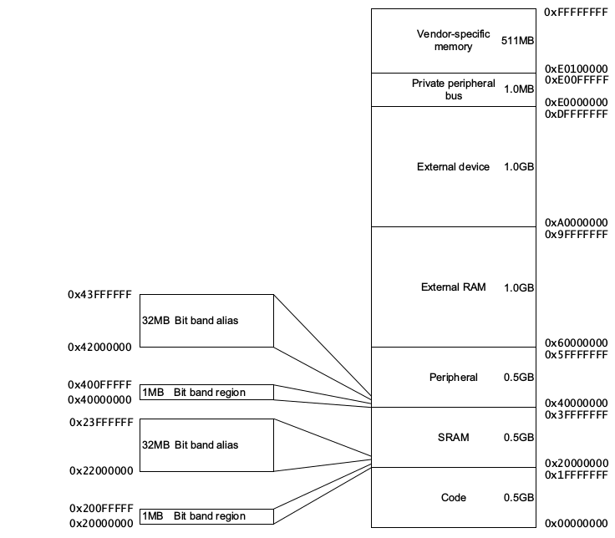

The regions for SRAM and peripherals include optional bit-band regions. Bit-banding provides
atomic operations to bit data.
The processor reserves regions of the Private Peripheral Bus (PPB) address range for core
peripheral registers.

The memory map and programming the optional MPU splits the memory map into regions.
Each region has a defined memory type, and some regions have additional memory attributes.
The memory type and attributes determine the behavior of accesses to the region.

The memory types are:
Normal - The processor can re-order transactions for efficiency, or perform speculative reads.
Device - The processor preserves transaction order relative to other transactions to Device or Strongly-ordered memory.
Strongly-ordered - The processor preserves transaction order relative to all other transactions.

The different ordering requirements for Device and Strongly-ordered memory mean that the
memory system can buffer a write to Device memory, but must not buffer a write to
Strongly-ordered memory.

The Code, SRAM, and external RAM regions can hold programs. However, ARM recommends
that programs always use the Code region. This is because the processor has separate buses that
enable instruction fetches and data accesses to occur simultaneously.

Instruction prefetch and branch prediction
The Cortex-M4 processor:
• prefetches instructions ahead of execution
• speculatively prefetches from branch target addresses.

Software ordering of memory accesses
The order of instructions in the program flow does not always guarantee the order of the
corresponding memory transactions. This is because:
• the processor can reorder some memory accesses to improve efficiency, providing this
does not affect the behavior of the instruction sequence.
• the processor has multiple bus interfaces
• memory or devices in the memory map have different wait states
• some memory accesses are buffered or speculative.

Optional bit-banding
A bit-band region maps each word in a bit-band alias region to a single bit in the bit-band
region. The bit-band regions occupy the lowest 1MB of the SRAM and peripheral memory
regions.
The memory map has two 32MB alias regions that map to two 1MB bit-band regions:
A word access to the SRAM or peripheral bit-band alias regions maps to a single bit in the
SRAM or peripheral bit-band region.
The following formula shows how the alias region maps onto the bit-band region:
bit_word_offset = (byte_offset x 32) + (bit_number x 4)
bit_word_addr = bit_band_base + bit_word_offset
Bit[0] of the value written to a word in the alias region determines the value written to the
targeted bit in the bit-band region. Writing a value with bit[0] set to 1 writes a 1 to the bit-band
bit, and writing a value with bit[0] set to 0 writes a 0 to the bit-band bit.

Memory endianness
The processor views memory as a linear collection of bytes numbered in ascending order from
zero. For example, bytes 0-3 hold the first stored word, and bytes 4-7 hold the second stored
word. The memory endianness used is implementation-defined, and the following subsections
describe the possible implementations:
•Byte-invariant big-endian format
•Little-endian format.
Read the AIRCR.ENDIANNESS field to find the implemented endianness.

Synchronization primitives
The Cortex-M4 instruction set includes pairs of synchronization primitives. These provide a
non-blocking mechanism that a thread or process can use to obtain exclusive access to a memory
location. Software can use them to perform a guaranteed read-modify-write memory update
sequence, or for a semaphore mechanism.

The pairs of Load-Exclusive and Store-Exclusive instructions are:
• the word instructions LDREX and STREX
• the halfword instructions LDREXH and STREXH
• the byte instructions LDREXB and STREXB

Q) Describe the exception model of Cortex-M4
or
Describe how Cortex-M4 handles exceptions.
Ans:
Exception states
Each exception is in one of the following states:
Inactive The exception is not active and not pending.
Pending The exception is waiting to be serviced by the processor. An interrupt request from a peripheral or from software can change the state of the corresponding interrupt to pending.
Active An exception that is being serviced by the processor but has not completed.
Active and pending The exception is being serviced by the processor and there is a pending
exception from the same source.

Exception Types

Reset Reset is invoked on power up or a warm reset. The exception model treats
reset as a special form of exception. When reset is asserted, the operation of the processor stops, potentially at any point in an instruction. When reset is deasserted, execution restarts from the address provided by the reset entry in the vector table. Execution restarts as privileged execution
in Thread mode.

NMI A Non Maskable Interrupt (NMI) can be signalled by a peripheral or triggered by software. This is the highest priority exception other than reset. It is permanently enabled and has a fixed priority of -2. NMIs cannot be:
•masked or prevented from activation by any other exception
•preempted by any exception other than Reset.

HardFault A HardFault is an exception that occurs because of an error during
exception processing, or because an exception cannot be managed by any
other exception mechanism. HardFaults have a fixed priority of -1,
meaning they have higher priority than any exception with configurable
priority.

MemManage A MemManage fault is an exception that occurs because of a memory protection related fault. The fixed memory protection constraints determines this fault, for both instruction and data memory transactions. This fault is always used to abort instruction accesses to Execute Never (XN) memory regions.

BusFault A BusFault is an exception that occurs because of a memory related fault for an instruction or data memory transaction. This might be from an error detected on a bus in the memory system.

UsageFault A UsageFault is an exception that occurs because of a fault related to
instruction execution. This includes:
•an undefined instruction
•an illegal unaligned access
•invalid state on instruction execution
•an error on exception return.

The following can cause a UsageFault when the core is configured to report them:
• an unaligned address on word and halfword memory access
• division by zero.

SVCall A supervisor call (SVC) is an exception that is triggered by the SVC instruction. In an OS environment, applications can use SVC instructions to access OS kernel functions and device drivers.

PendSV PendSV is an interrupt-driven request for system-level service. In an OS environment, use PendSV for context switching when no other exception is active.

SysTick A SysTick exception is an exception the system timer generates when it reaches zero. Software can also generate a SysTick exception. In an OS environment, the processor can use this exception as system tick.

Interrupt (IRQ) A interrupt, or IRQ, is an exception signalled by a peripheral, or generated
by a software request. All interrupts are asynchronous to instruction execution. In the system, peripherals use interrupts to communicate with the processor.

Exception handlers
The processor handles exceptions using:
Interrupt Service Routines (ISRs)
The IRQ interrupts are the exceptions handled by ISRs.
Fault handlers
HardFault, MemManage fault, UsageFault, and BusFault are fault exceptions handled by the fault handlers.
System handlers
NMI, PendSV, SVCall SysTick, and the fault exceptions are all system exceptions that are handled by system handlers.

Vector table
The vector table contains the reset value of the stack pointer, and the start addresses, also called
exception vectors, for all exception handlers.

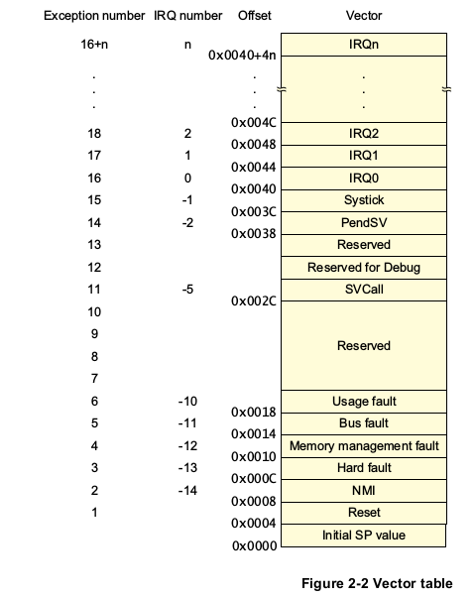

On system reset, the vector table is fixed at address 0x00000000 . Privileged software can write to
the VTOR to relocate the vector table start address to a different memory location, in the range
0x00000080 to 0x3FFFFF80.

Exception priorities
All exceptions have an associated priority, with:
• a lower priority value indicating a higher priority
• configurable priorities for all exceptions except Reset, HardFault, and NMI.

If software does not configure any priorities, then all exceptions with a configurable priority
have a priority of 0. Configurable priority values are in the range 0-. This means that the Reset, HardFault, and NMI exceptions, with fixed negative priority values, always have higher priority than any other exception.

If multiple pending exceptions have the same priority, the pending exception with the lowest
exception number takes precedence. For example, if both IRQ[0] and IRQ[1] are pending and
have the same priority, then IRQ[0] is processed before IRQ[1].

When the processor is executing an exception handler, the exception handler is preempted if a
higher priority exception occurs. If an exception occurs with the same priority as the exception
being handled, the handler is not preempted, irrespective of the exception number. However, the
status of the new interrupt changes to pending.

Exception entry and return

Preemption
When the processor is executing an exception handler, an exception can preempt the exception handler if its priority is higher than the priority of the exception being handled.
When one exception preempts another, the exceptions are called nested exceptions.

Return
This occurs when the exception handler is completed, and:
• there is no pending exception with sufficient priority to be serviced
• the completed exception handler was not handling a late-arriving exception.
The processor pops the stack and restores the processor state to the state it had before the interrupt occurred.

Tail-chaining
This mechanism speeds up exception servicing. On completion of an exception handler, if there is a pending exception that meets the requirements for exception entry, the stack pop is skipped and control transfers to the new exception handler.

Late-arriving
This mechanism speeds up preemption. If a higher priority exception occurs during state saving for a previous exception, the processor switches to handle the higher priority exception and initiates the vector fetch for that exception. State saving is not affected by late arrival because the state saved is the same for both exceptions. Therefore the state saving continues uninterrupted. The processor can accept a late arriving exception until the first instruction of the exception handler of the original exception enters the execute stage of the processor. On return from the exception handler of the late-arriving exception, the normal tail-chaining rules apply.

Exception entry occurs when there is a pending exception with sufficient priority and either:
• the processor is in Thread mode
• the new exception is of higher priority than the exception being handled, in which case
the new exception preempts the original exception.
When one exception preempts another, the exceptions are nested.

Sufficient priority means the exception has more priority than any limits set by the mask
registers. An exception with less priority than this is pending but is not handled by the processor.

When the processor takes an exception, unless the exception is a tail-chained or a late-arriving
exception, the processor pushes information onto the current stack. This operation is referred to
as stacking and the structure of eight data words is referred as the stack frame.

When using floating-point routines the Cortex-M4 processor automatically stacks the
architected floating-point state on exception entry.

Immediately after stacking, the stack pointer indicates the lowest address in the stack frame. The
alignment of the stack frame is controlled using the STKALIGN bit of the Configuration
Control Register (CCR).

The stack frame includes the return address. This is the address of the next instruction in the
interrupted program. This value is restored to the PC at exception return so that the interrupted
program resumes.

In parallel to the stacking operation, the processor performs a vector fetch that reads the
exception handler start address from the vector table. When stacking is complete, the processor
starts executing the exception handler. At the same time, the processor writes an
EXC_RETURN value to the LR. This indicates which stack pointer corresponds to the stack
frame and what operation mode the processor was in before the entry occurred.

Exception return
Exception return occurs when the processor is in Handler mode and executes one of the
following instructions to load the EXC_RETURN value into the PC:
• an LDM or POP instruction that loads the PC
• an LDR instruction with PC as the destination
• a BX instruction using any register.

EXC_RETURN is the value loaded into the LR on exception entry. The exception mechanism
relies on this value to detect when the processor has completed an exception handler. The lowest
five bits of this value provide information on the return stack and processor mode.

All EXC_RETURN values have bits[31:5] set to one. When this value is loaded into the PC it
indicates to the processor that the exception is complete, and the processor initiates the
appropriate exception return sequence.

Q) Describe the fault-handling mechanisms in Cortex-M4?
Ans:
Faults are a subset of the exceptions. Faults are generated by:
• a bus error on:
— an instruction fetch or vector table load
— a data access.
• an internally-detected error such as an undefined instruction
• attempting to execute an instruction from a memory region marked as Execute-never
(XN).
• If your device contains an MPU, a privilege violation or an attempt to access an
unmanaged region causing an MPU fault.

Usually, the exception priority, together with the values of the exception mask registers,
determines whether the processor enters the fault handler, and whether a fault handler can
preempt another fault handler.

In some situations, a fault with configurable priority is treated as a HardFault. This is called
priority escalation, and the fault is described as escalated to HardFault. Escalation to HardFault
occurs when:
•
A fault handler causes the same kind of fault as the one it is servicing. This escalation to
HardFault occurs because a fault handler cannot preempt itself because it must have the
same priority as the current priority level.
•
A fault handler causes a fault with the same or lower priority as the fault it is servicing.
This is because the handler for the new fault cannot preempt the currently executing fault
handler.
•
An exception handler causes a fault for which the priority is the same as or lower than the
currently executing exception.
•
A fault occurs and the handler for that fault is not enabled.

If a BusFault occurs during a stack push when entering a BusFault handler, the BusFault does
not escalate to a HardFault. This means that if a corrupted stack causes a fault, the fault handler
executes even though the stack push for the handler failed. The fault handler operates but the
stack contents are corrupted.
Only Reset and NMI can preempt the fixed priority HardFault. A HardFault can preempt any
exception other than Reset, NMI, or another HardFault.

Fault status registers and fault address registers
The fault status registers indicate the cause of a fault. For BusFaults and MemManage faults,
the fault address register indicates the address accessed by the operation that caused the fault.

Lockup
The processor enters a lockup state if a fault occurs when executing the NMI or HardFault
handlers. When the processor is in lockup state it does not execute any instructions. The
processor remains in lockup state until either:
• it is reset
• an NMI occurs
• it is halted by a debugger.

If lockup state occurs from the NMI handler a subsequent NMI does not cause the processor to
leave lockup state.

Q) Describe the features that make Cortex-M processors suitable for low-power applications?
Ans:
The Cortex-M4 processor sleep modes reduce power consumption. The sleep modes your
device implements are implementation-defined. The modes can be one or both of the following:
• sleep mode stops the processor clock
• deep sleep mode stops the system clock and switches off the PLL and flash memory.
If your device implements two sleep modes providing different levels of power saving, the
SLEEPDEEP bit of the SCR selects which sleep mode is used.

Wait for interrupt
The Wait For Interrupt instruction, WFI , causes immediate entry to sleep mode unless the
wake-up condition is true. When the processor executes a WFI instruction it stops executing instructions and enters sleep mode.

Wait for event
The Wait For Event instruction, WFE , causes entry to sleep mode depending on the value of a
one-bit event register. When the processor executes a WFE instruction, it checks the value of the
event register:
0 The processor stops executing instructions and enters sleep mode.
1 The processor clears the register to 0 and continues executing instructions without entering sleep mode.
If the event register is 1, this indicates that the processor must not enter sleep mode on execution
of a WFE instruction. Typically, this is because an external event signal is asserted, or a processor
in the system has executed an SEV instruction.

Sleep-on-exit
If the SLEEPONEXIT bit of the SCR is set to 1, when the processor completes the execution of
all exception handlers it returns to Thread mode and immediately enters sleep mode. Use this
mechanism in applications that only require the processor to run when an exception occurs.
The CMSIS provides the following functions for these instructions:
void __WFE(void) // Wait for Event
void __WFI(void) // Wait for Interrupt
Q) Describe how the Cortex-M wakes up from sleep mode?
Ans:
The conditions for the processor to wakeup depend on the mechanism that cause it to enter sleep
mode.

Wakeup from WFI or sleep-on-exit
Normally, the processor wakes up only when it detects an exception with sufficient priority to
cause exception entry. Some embedded systems might have to execute system restore tasks after
the processor wakes up, and before it executes an interrupt handler. To achieve this set the
PRIMASK bit to 1 and the FAULTMASK bit to 0. If an interrupt arrives that is enabled and has
a higher priority than current exception priority, the processor wakes up but does not execute the
interrupt handler until the processor sets PRIMASK to zero.

Wakeup from WFE
The processor wakes up if:
• it detects an exception with sufficient priority to cause exception entry
• it detects an external event signal
• in a multiprocessor system, another processor in the system executes an SEV instruction.

In addition, if the SEVONPEND bit in the SCR is set to 1, any new pending interrupt triggers
an event and wakes up the processor, even if the interrupt is disabled or has insufficient priority
to cause exception entry.

Your device might include a Wakeup Interrupt Controller (WIC), an optional peripheral that can
detect an interrupt and wake the processor from deep sleep mode. The WIC is enabled only
when the DEEPSLEEP bit in the SCR is set to 1.
The WIC is not programmable, and does not have any registers or user interface. It operates
entirely from hardware signals.
If the processor detects a connection to a debugger it disables the WIC.

The external event input
Your device might include an external event input signal, so that device peripherals can signal
the processor, to either:
• wake the processor from WFE
• set the internal WFE event register to one to indicate that the processor must not enter
sleep mode on a later WFE instruction.

Q) Features of NVIC
Ans:
The NVIC supports:
• An implementation-defined number of interrupts, in the range 1-240 interrupts.
• A programmable priority level of 0-255 for each interrupt. A higher level corresponds to
a lower priority, so level 0 is the highest interrupt priority.
• Level and pulse detection of interrupt signals.
• Dynamic reprioritization of interrupts.
• Grouping of priority values into group priority and subpriority fields.
• Interrupt tail-chaining.
• An external Non Maskable Interrupt (NMI)
• Optional WIC, providing ultra-low power sleep mode support.
The processor automatically stacks its state on exception entry and unstacks this state on
exception exit, with no instruction overhead. This provides low latency exception handling.

NVIC Registers

Interrupt Set-enable Registers
The NVIC_ISER0-NVIC_ISER7 registers enable interrupts, and show which interrupts are
enabled.

Interrupt Clear-enable Registers
The NVIC_ICER0-NVIC_ICER7 registers disable interrupts, and show which interrupts are
enabled.

Interrupt Set-pending Registers
The NVIC_ISPR0-NVIC_ISPR7 registers force interrupts into the pending state, and show
which interrupts are pending.

Interrupt Clear-pending Registers
The NVIC_ICPR0-NCVIC_ICPR7 registers remove the pending state from interrupts, and
show which interrupts are pending.

Interrupt Active Bit Registers
The NVIC_IABR0-NVIC_IABR7 registers indicate which interrupts are active.

Interrupt Priority Registers
The NVIC_IPR0-NVIC_IPR59 registers provide an 8-bit priority field for each interrupt and
each register holds four priority fields. These registers are byte-accessible.

Software Trigger Interrupt Register
Write to the STIR to generate an interrupt from software. Only privileged software can enable unprivileged access to the STIR.
[8:0] INTID Interrupt ID of the interrupt to trigger, in the range 0-239.

The Cortex-M4 latches all interrupts. A peripheral interrupt becomes pending for one of the
following reasons:
• the NVIC detects that the interrupt signal is HIGH and the interrupt is not active
• the NVIC detects a rising edge on the interrupt signal
• software writes to the corresponding interrupt set-pending register bit
or to the STIR to make an interrupt pending

Software uses the CPSIE I and CPSID I instructions to enable and disable interrupts. The
CMSIS provides the following intrinsic functions for these instructions:
void __disable_irq(void) // Disable Interrupts
void __enable_irq(void) // Enable Interrupts

Q) Describe the features and registers of SCB in Cortex-M4?
Ans:
The System Control Block (SCB) provides system implementation information, and system
control. This includes configuration, control, and reporting of the system exceptions.

Q) Describe the features of MPU in Cortex-M4.
Ans:
The MPU divides the memory map into a number of regions, and defines the location, size,
access permissions, and memory attributes of each region. It supports:
• independent attribute settings for each region
• overlapping regions
• export of memory attributes to the system.

The memory attributes affect the behavior of memory accesses to the region. The Cortex-M4
MPU defines:
• eight separate memory regions, 0-7
• a background region.

When memory regions overlap, a memory access is affected by the attributes of the region with
the highest number.
The background region has the same memory access attributes as the default memory map, but
is accessible from privileged software only.

If a program accesses a memory location that is prohibited by the MPU, the processor generates
a MemManage fault. This causes a fault exception, and might cause termination of the process
in an OS environment. In an OS environment, the kernel can update the MPU region setting
dynamically based on the process to be executed. Typically, an embedded OS uses the MPU for
memory protection.

Q) Describe the Cortex-M4 FPU and associated registers
Ans:
The FPU implements the FPv4-SP floating-point extension. The FPU fully supports single-precision add, subtract, multiply, divide, multiply and accumulate, and square root operations. It also provides conversions between fixed-point and floating-point data formats, and floating-point constant instructions. The FPU provides floating-point computation functionality that is compliant with the IEEE 754 standard.

The FPU contains 32 single-precision extension registers, which you can also access as 16
doubleword registers for load, store, and move operations.

Registers

Coprocessor Access Control Register
The CPACR register specifies the access privileges for coprocessors.
CP[11:10] 00 Access denied. Any attempted access generates a NOCP UsageFault.
01 Privileged access only. An unprivileged access generates a NOCP fault.
10 Reserved. The result of any access is Unpredictable.
11 Full access.

Floating-point Context Control Register
The FPCCR register sets or returns FPU control data

Floating-point Context Address Register
The FPCAR register holds the location of the unpopulated floating-point register space
allocated on an exception stack frame.

Floating-point Status Control Register
The FPSCR register provides all necessary User level control of the floating-point system.

Floating-point Default Status Control Register
The FPDSCR register holds the default values for the floating-point status control data.

Enabling the FPU
The FPU is disabled from reset. You must enable it before you can use any floating-point
instructions.
The processor must be in privileged mode to read from and write to the CPACR.

; CPACR is located at address 0xE000ED88
LDR.W R0, =0xE000ED88
; Read CPACR
LDR R1, [R0]
; Set bits 20-23 to enable CP10 and CP11 coprocessors
ORR R1, R1, #(0xF << 20)
; Write back the modified value to the CPACR
STR R1, [R0]
; wait for store to complete
DSB
;reset pipeline now the FPU is enabled
ISB

Q) Difference between write-through, write-back and write-around cache?
Ans:
Cache, the technique of storing a copy of data temporarily in rapidly-accessible storage media (also known as memory) local to the central processing unit (CPU) and separate from bulk storage.

A cache, in computing, is a data storing technique that provides the ability to access data or files at a higher speed.
Caches are implemented both in hardware and software. Caching serves as an intermediary component between the primary storage appliance and the recipient hardware or software device to reduce the latency in data access

A cache works in both hardware and software to provide similar functionality. In its physical or hardware form, it is a small form factor of internal memory that stores instances of the most frequently executed programs in the main memory to enable faster access when they are requested by the CPU.

Write-through cache is a caching technique in which data is simultaneously copied to higher level caches, backing storage or memory. It is common in processor architectures that perform a write operation on cache and backing stores at the same time.
Write-through cache helps increase read performance in memory access methods because the requested data is already present in the cache and memory.
In each write-through operation, data that is brought into the cache is also written into the backing store, which is the primary memory (RAM, in most cases).

Write-back cache is a caching technique common in most processor architectures since Intel 80486. When required, it copies data to higher level caches, backing store or memory. Write-back cache is also known as write-behind cache and copy-back cache.
Write-back cache is designed to improve or reduce write operations from and to a cache and its data source (RAM, in most cases). It enables control of the time and the frequency at which data is written or copied into the source backing store.
In a write-back operation, any new, requested processor data is written to the cache, but not in the memory. The memory write process is only performed when the cache data needs to be edited or purged for new content.

Q) What is L1 cache, L2 cache and L3 cache?
Ans:

L1 Cache
A level 1 cache (L1 cache) is a memory cache that is directly built into the microprocessor, which is used for storing the microprocessor’s recently accessed information, thus it is also called the primary cache. It is also referred to as the internal cache or system cache.
L1 cache is the fastest cache memory, since it is already built within the chip with a zero wait-state interface, making it the most expensive cache among the CPU caches. However, it has limited size. It is used to store data that was accessed by the processor recently, critical files that need to be executed immediately and it is the first cache to be accessed and processed when the processor itself performs a computer instruction.
In more recent microprocessors, the L1 cache is divided equally into two: a cache that is used to keep program data and another cache that is used to keep instructions for the microprocessor.
It is implemented with the use of static random access memory (SRAM), which comes in different sizes depending on the grade of the processor. This SRAM makes use of two transistors per bit. The two transistors form a circuit known as a 'flip-flop’ since it has two states it can flip between; the second transistor manages the output of the first transistor. For as long as power is supplied to the circuit, it can hold data without external assistance.
All L1 cache designs follow the same process; the control logic of the L1 cache stores frequently used data in the cache and only updates external memory when the CPU hands over control to other bus masters when peripheral devices are doing direct memory access.

L2 Cache
A level 2 cache (L2 cache) is a CPU cache memory that is located outside and separate from the microprocessor chip core, although, it is found on the same processor chip package. Earlier L2 cache designs placed them on the motherboard which made them quite slow.
Including L2 caches in microprocessor designs are very common in modern CPUs even though they may not be as fast as the L1 cache, but since it is outside of the core, the capacity can be increased and it is still faster than the main memory.
A level 2 cache is also called the secondary cache or an external cache.

The level 2 cache serves as the bridge for the process and memory performance gap. Its main goal is to provide the necessary stored information to the processor without any interruptions or any delays or wait-states. It also helps in reducing the access time of data, especially in certain events wherein that specific data was already accessed before, so it doesn’t have to be loaded again.
Modern microprocessors sometimes include a feature called data pre-fetching, and the L2 cache boosts this feature by buffering the program instructions and data that is requested by the processor from the memory, serving as a closer waiting area compared to the RAM.
Although it is not as fast as the L1 cache due to its location, it is still faster than both L3 cache and the main memory. It is also the second priority of the computer when looking at its performance in implementing instructions.

L3 Cache
A Level 3 (L3) cache is a specialized cache that is used by the CPU and is usually built onto the motherboard and, in certain special processors, within the CPU module itself. It works together with the L1 and L2 cache to improve computer performance by preventing bottlenecks due to the fetch and execute cycle taking too long. The L3 cache feeds information to the L2 cache, which then forwards information to the L1 cache. Typically, its memory performance is slower compared to L2 cache, but is still faster than the main memory (RAM).

The L3 cache is usually built onto the motherboard between the main memory (RAM) and the L1 and L2 caches of the processor module. This serves as another bridge to park information like processor commands and frequently used data in order to prevent bottlenecks resulting from the fetching of these data from the main memory.

The purpose of the L3 differs depending on the design of the CPU. In some cases the L3 holds copies of instructions frequently used by multiple cores that share it. Most modern CPUs have built-in L1 and L2 caches per core and share a single L3 cache on the motherboard, while other designs have the L3 on the CPU die itself.

Q) Firmware vs Bootloader
Ans:
The firmware is the deeply embedded, low-level software that provides an interface between the hardware and the application/operating system level software. It resides in the ROM and executes when power is applied to the embedded hardware system. Firmware can remain active after system initialization and supports basic system operations.

The bootloader is a small application that installs the operating system or application onto a hardware target. The bootloader only exists up to the point that the operating system or application is executing, and it is commonly incorporated into the firmware.

Q) Firmware Execution flow
Ans:
Firmware execution flow.
Stage Features
Set up target platform Program the hardware system registers
Platform identification
Diagnostics
Debug interface
Command line interpreter
Abstract the hardware Hardware Abstraction Layer
Device driver
Load a bootable image Basic filing system
Relinquish control Alter the pc to point into the new image

The first stage is to set up the target platform—in other words, prepare the environ-
ment to boot an operating system since an operating system expects a particular type
of environment before it can operate. This step involves making sure that the platform
is correctly initialized

The second stage is to abstract the hardware. The Hardware Abstraction Layer (HAL) is
a software layer that hides the underlying hardware by providing a set of defined pro-
gramming interfaces.
The HAL software that communicates with specific hardware peripherals is called a
device driver. A device driver provides a standard application programming interface (API)
to read and write to a specific peripheral.

The third stage is to load a bootable image. The ability of firmware to carry out this
activity depends upon the type of media used to store the image. Note that not all operating
system images or application images need to be copied into RAM. The operating system
image or application image can simply execute directly from ROM.
The load process has to take into account the image format. The most basic image format
is plain binary. A plain binary image does not contain any header or debug information.
A popular image format for ARM-based systems is Executable and Linking Format (ELF).
This format was originally developed for UNIX systems and replaced the older format
called Common Object File Format (COFF). ELF files come in three forms: relocatable,
executable, and shared object.

The fourth stage is to relinquish control. This is where the firmware hands over control
of the platform to an operating system or application. Note that not all firmware hands
over control; instead the firmware can remain the controlling software on the platform.

Q) What is AMBA?
Ans:
Advanced Microcontroller Bus Architecture (AMBA) is a collection of on-chip bus protocol specifications used by Arm processors as well as a wide range of on-chip digital components such as memory interfaces, peripherals and debug components. The specification is developed by Arm and is an open standard available to the chip design industry.

AMBA bus protocols are designed for on-chip communications. To enable easier system integration inside chip designs, almost all the AMBA specifications have the following characteristics:
  Synchronous operations – use only clock rising edge for flip-flops, friendly to common synthesis flow;
  No on-chip bi-directional signals – avoiding the need for tri-state buffers.
The most common AMBA bus protocols used in microcontrollers include:
  AHB (Advanced High-performance Bus) – a lightweight pipelined bus protocol used in the majority of the Arm Cortex-M processors.
  APB (Advanced Peripheral Bus) – a simple bus protocol for connecting general simple peripherals
with low data bandwidth requirements.
  AXI (Advanced eXtensible Interface) – a high-performance bus protocol for efficient, high-
performance processors including the Cortex-M7 processor, Cortex-R processors and the majority
of the Arm Cortex-A processors. The AXI protocol:
-Provides multiple data channels running concurrently at high clock frequency.
-Allows new transfers to be issued and take place even with previous transfers still outstanding.
-Supports unaligned data and provides data security based on TrustZone technology.

Q) Data abort exception in ARM?
Ans:
A data-abort exception is a response by a memory system to an invalid data access. The data-abort exception handler is a program that can inform the programmer where in his or her code this exception has occurred (after the application has crashed). The exception handler ought to handle the consequences of the aborted instruction gracefully, rather than forcing the processor to hang in an infinite loop.
These exceptions may originate in software, such as improper C-structures, or appear in code ported from a different processor architecture. Alternatively, exceptions may become signs of improper memory system design or manifestations of environmental effects on a marginal hardware design or on a specific component.

